**Optimization of the facility layout**

**Case of SITA steel rolling company**

**Final Year Project - Proposal**

**By**

**Mtui, Believe Telesphory**

**B. Sc. Industrial Engineering**

**University of Dar es Salaam**

**February, 2025**

# INFORMATION PAGE

**IE498: Final Year Project I**

|  |  |
| --- | --- |
| **Title of the Project:** | Optimization of the facility layout to improve productivity, case of SITA steel rolling company |
| **Name of the student:** | Mtui, Believe Telesphory |
| **Registration number:** | 2021-04-08264 |
| **Degree Program:** | B. Sc. Industrial Engineering |
| **Department:** | Mechanical and Industrial Engineering |
| **Academic Unit:** | Management |
| **Supervisor:** | Dr. M. Nnko |
| **Co-Supervisor:** | Dr. J. Kafuku |
| **Project Number:** | IEM-2025-17 |

**Supervisor’s approval for submission:**

I have reviewed the student’s report and approve for submission for examination

**Name: ……………………………………….**

**Signature: …………………………………….**

**Date: …………………………………………**

# Acknowledgement

I would like to express my sincere gratitude to all those who contributed to the successful completion of this research project. My deepest appreciation goes to my supervisor, Dr. M. Nnko, for their invaluable guidance, support, and insightful feedback throughout the study. I am also grateful to the management and staff of SITA Steel Rolling Company for providing the necessary data and allowing access to their facility. Special thanks to my family, friends, and colleagues for their encouragement and moral support during this journey. Without the collective efforts of all these individuals, this project would not have been possible.

# Executive Summary

This research focuses on optimizing the facility layout of **SITA Steel Rolling Company** to enhance productivity, reduce material handling costs, and improve workflow efficiency. The study employs **systematic data collection methods**, including direct observations, time-motion studies, and computational analysis using simulation tools like **ARENA and FlexSim**.. Key performance metrics such as **material handling costs, space utilization, and worker movement efficiency** are analyzed to compare existing and proposed layouts. The findings indicate that the optimized layout significantly reduces congestion, enhances resource utilization, and minimizes operational costs, ultimately improving overall productivity. The study concludes that a **data-driven, simulation-based approach** is effective in designing an optimal facility layout that aligns with industry best practices and operational needs.

**Table of Contents**

INFORMATION PAGE i

Acknowledgement ii

Executive Summary iii

List of Equations vi

List of Figures vii

List of Tables viii

CHAPTER ONE 1

1.0 Introduction 1

1.1 Problem Statement 2

1.2 Research Objectives 3

1.2.1 Main objective 3

1.2.2 Specific objectives 3

1.3 Research Question 3

1.4 Scope of the project 3

1.5 Significant of the project. 4

CHAPTER TWO 5

2.0 LITERATURE REVIEW 5

2.1 Facility Layout Design 5

2.2 Critical parameters to be considered when developing the efficient factory layout. 6

2.3 Design Strategies and Approaches for Efficient Factory Layouts 7

2.3.1 Systematic Layout Planning (SLP) 8

2.3.2 Hybrid Models Combining Traditional and Simulation Techniques 8

2.3.3 Focus on Material Flow and Workflow Efficiency 8

2.3.4 Integration of Resilience and Flexibility 9

2.3 5. Advanced Computational Tools 9

2.4 Methods and Techniques Used in Developing Facility Layouts 9

2.4.1 Traditional Methods 10

2.4.1.1 Systematic Layout Planning (SLP). 10

2.4.1.2 Computerized Relative Allocation of Facilities Technique (CRAFT) 11

2.4.2 Simulation-Based Techniques 12

2.4.2.1ARENA and FlexSim. 12

2.4.3 Hybrid Approaches for Layout Improvement 15

CRAFT and ARENA 15

2.5 Research Implications and Future Directions. 15

CHAPTER THREE 16

METHODOLOGY 16

3.1 Research Design 16

3.2 Data Collection Methods 16

3.2.1 Document analysis 16

3.2.2 Direct Observations: 17

3.2.3 Time-Motion Studies: 22

3.2.4 Facility Blueprints and Layout Diagrams: 23

3.3 Data Analysis Methods 24

3.3.1 Microsoft Excel. 25

3.3.2 ARENA Simulation Analysis 25

3.3.3 FlexSim Simulation Analysis 26

3.4 Facility Layout Genetic Algorithm optimization 27

3.5 Performance Metrics for Evaluation 34

3.6 Validation and Implementation Strategy 35

CHAPTER FOUR 36

RESULT AND CONCLUSION 36

REFERENCE 37

APPENDICES 39

Appendix I: Research Budget 39

Appendix Ⅱ: Showing the Timeline of Project 40

# List of Equations

Equation 1:Total Cost 12

# List of Figures

Figure 1:Showing Arena analysis 21

Figure 2:Showing FlexSim Simulation analysis 22

Figure 3:Showing the Timeline of Project 28

# List of Tables

Table 1:showing data collection design for department size 17

Table 2:showing data collection design for distance (Dij) between department 18

Table 3:showing data collection design on number of flow (Fij) between process 19

Table 4:showing data collection design for cost (Cij) 19

Table 5:Summary of methodology 23

Table 6:showing the project Budget 27

##### List of Symbols

|  |  |  |
| --- | --- | --- |
| Symbol | Description | Units |
| fij | flow from department i to department j, | Meters |
| dij | the distance from department i to department j | Meters |
| cij | the cost per unit of travel. | TShs |
| Di | representing a “i” department | - |
|  |  |  |
|  |  |  |
|  |  |  |
|  |  |  |
|  |  |  |
|  |  |  |
|  |  |  |
|  |  |  |
|  |  |  |
|  |  |  |
|  |  |  |
|  |  |  |
|  |  |  |
|  |  |  |
|  |  |  |
|  |  |  |
|  |  |  |
|  |  |  |

##### List of Abbreviations and Acronyms

|  |  |
| --- | --- |
| Abbreviation | Description |
| JIT | Just-In-Time |
| FMS | Flexible Manufacturing System |
| OPT | Optimized Production Technology |
| TQM | Total Quality Management |
| FIFO | First-In, First-Out |
| LIFO | Last-In, First-Out |
| SPT | Shortest Processing Time |
| SDEA | Stochastic Data Envelopment Analysis |
| FLP | Facility Layout Problem |
| SLP | Systematic Layout Planning |
| ARC | Activity Relationship Charts |
| CRAFT | Computerized Relative Allocation of Facilities Technique |
| GA | Genetic Algorithms |
| ARD | Activity Relationship Diagrams |
| DES | discrete-event simulation |
| CAD | Computer Aided Design |
|  |  |
|  |  |
|  |  |
|  |  |
|  |  |
|  |  |

# CHAPTER ONE

# 1.0 Introduction

The layout of a manufacturing facility significantly impacts its operational efficiency, productivity, and adaptability to changing production demands. Facility layout planning involves the systematic arrangement of machinery, equipment, and workstations to optimize the flow of materials, processes, and labor while minimizing movements and routes, time process and costs(Patil et al., 2015). At SITA Steel Industry, the need for an optimized facility layout has become increasingly crucial to address challenges such as workflow congestion, excessive material handling, and underutilized space. These inefficiencies not only hinder the plant’s productivity but also increase operational costs and worker fatigue, making it essential to redesign the current layout for enhanced performance.

An effective facility layout reduces production delays, increases worker efficiency, and minimizes operational costs. Poor layouts often lead to longer travel distances for materials, increased handling time, and higher labor costs. These problems affect productivity and create safety risks for workers. Redesigning the layout can help to address these challenges and support the company in achieving its production goals.

Many industries use advanced tools and techniques such as optimization algorithms and simulation software to improve layouts. Tools like FlexSim and AnyLogic allow companies to model and test layouts before implementation. However, such methods are not commonly applied in small and medium-sized industries due to limited resources and expertise. SITA Steel Industry faces similar challenges, highlighting the need for a practical and affordable approach to layout improvement.

The redesigning concept as being conducted mostly based in the use of optimization algorithm to address dynamic and complex facility layout problems in real world environment(Kovács & Kot, 2017). They lack the use of comprehensive evaluation of re-layout impacts using modern computational tools such as FlexSim, “AnyLogic” which involves the combination of system dynamic, agent-based and discrete event modelling.

This study focuses on redesigning the facility layout at SITA Steel Industry to improve material flow, reduce handling costs, and make better use of available space. It will evaluate critical factors such as safety, communication, and workflow efficiency. The project aims to create a flexible layout that can meet current and future production needs.

By using data from observations, interviews, and factory records, the study will analyze the existing layout and develop an improved design. Simulation and optimization tools will help to create and evaluate alternatives. The results will provide a detailed plan for implementation, ensuring the company achieves higher productivity and better resource utilization.

# 1.1 Problem Statement

The efficient arrangement of machinery, workstations, and storage areas within a factory is critical to optimizing productivity, reducing costs, and ensuring smooth workflow. Research shows that well-designed facility layouts can significantly minimize material handling distances, enhance operational efficiency, and improve space utilization. Various methods, including simulation tools and optimization algorithms, have been successfully applied in many industries to tackle facility layout problems. However, despite advancements in layout planning, many factories still operate with layouts that are not aligned with current production demands and workflow requirements.

At SITA Steel Industry, the existing facility layout faces challenges such as excessive material handling distances, poor space utilization, and workflow bottlenecks. These issues contribute to increased operational costs, increase of work safety issues, delays in production, and inefficient use of available space. Although prior studies and tools provide valuable insights into facility layout optimization, the application of these methods in dynamic and resource-constrained environments like SITA Steel's context remains insufficiently explored. Therefore, there is a need for a systematic evaluation of the factory's critical parameters such as floor space utilization, work safety, communication and practical solutions tailored to its unique production processes.

To address this gap, this study aims to redesign the facility layout at SITA Steel Industry by evaluating critical parameters, reducing material handling costs and distances, and enhancing space utilization. The proposed solution involves the use of computerized tools, computational tools and performance metrics to develop and implement an optimized layout. This redesign will improve workflow efficiency, reduce costs, and provide flexibility for future production demands.

# 1.2 Research Objectives

## 1.2.1 Main objective

To develop an optimized facility layout for Sita Steel Rolling company.

## 1.2.2 Specific objectives

1. To identify the critical parameters for the efficient factory layout.
2. To evaluate the facility design strategies and approaches.
3. To develop the new facility layout

# 1.3 Research Question

1. what critical parameters should be considered when developing the efficient factory layout?
2. What design strategies and approach to develop the efficient factory layout?
3. What methods and techniques used in developing the facility layout?

# 1.4 Scope of the project

The project includes an evaluation of the current layout, identification of inefficiencies in material handling, workflow, and space utilization, and the development of an optimized layout. The report considers critical parameters such as material flow distances, handling costs, production throughput, and floor space utilization.

The scope is limited to the manufacturing processes and associated activities within the factory floor. It excludes aspects such as office layouts, administrative functions, and external logistics. The study leverages data collected from observations, interviews, and secondary sources such as production reports and facility blueprints. Computational tools like simulation and optimization software are used to analyze the data and generate layout alternatives. The final layout recommendations are tailored to the factory's current needs and potential future expansion.

# 1.5 Significant of the project.

This project is highly significant as it aims to optimize the facility layout of SITA Steel Industry to enhance operational efficiency and productivity. By analyzing the current layout and identifying inefficiencies, the project focuses on reducing material handling distances, minimizing transportation costs, and eliminating workflow bottlenecks. These improvements not only streamline operations but also lower production costs, contributing to a more competitive and cost-effective manufacturing process. Enhancing layout efficiency ensures smoother transitions between production stages, reduces idle time, and improves resource utilization, leading to increased output and profitability.

Furthermore, the project supports future scalability and adaptability by designing a flexible layout that can accommodate growth, technological advancements, and changes in production demands. This ensures that SITA Steel Industry remains competitive and capable of meeting market requirements without requiring extensive modifications to its infrastructure. Additionally, the project enhances workplace safety and ergonomics by reducing congestion, organizing workspaces, and promoting safer working conditions, which ultimately improves employee morale, reduces fatigue, and lowers accident risks.

From a broader perspective, this project contributes to sustainability by reducing material waste, optimizing energy consumption, and supporting lean manufacturing principles. It also demonstrates the integration of modern computational tools and optimization techniques, such as simulation software and Genetic Algorithms, to solve complex industrial problems. The findings from this study provide a practical framework that can be replicated in other industries facing similar layout challenges, making it a valuable reference for researchers, engineers, and manufacturers striving for operational excellence and cost efficiency.

# CHAPTER TWO

# 2.0 LITERATURE REVIEW

Facility layout is the physical arrangement of machines in a facility. The efficiency and feasibility of a facility layout depend on how the machines are arranged and if there is enough space for each machine. Efficient facility layout can improve productivity and overall efficiency of a production line. Poor facility layout can result in material waste, long lead times, and machine failure. There are management techniques that can improve facility layout, such as Just-In-Time (JIT), Flexible Manufacturing System (FMS), Optimized Production Technology (OPT), and Total Quality Management (TQM).(Sharma & Sharma, 2022)

Facility layout refers to the arrangement of physical facilities, such as machinery and equipment, to achieve the fastest flow of materials at the lowest cost1. It is a crucial factor in a company's performance as it supports a streamlined production process. The cost of moving material can contribute 30–90% of total production costs(Suhardi et al., 2019)

# 2.1 Facility Layout Design

Facility layout design plays a critical role in manufacturing, as it directly impacts the overall performance and efficiency of a facility. The layout involves strategically arranging key elements such as machine tools, workbenches, and storage areas within the available space on the manufacturing floor. A well-planned layout ensures that manufacturing processes run smoothly and efficiently, aligning with the specific needs of production activities.

The benefits of an effective layout are substantial. It facilitates the easy movement of materials and personnel between stations, enhances production efficiency, and reduces lead times. Additionally, a well-designed layout helps to minimize health and safety risks for workers, creating a safer and more productive work environment. On the other hand, an inefficient layout can lead to increased levels of work-in-progress, longer manufacturing lead times, and bottlenecks or congestion that disrupt the flow of operations.

Businesses aim to create layouts that optimize manufacturing processes, allowing them to meet production demands efficiently while keeping costs low and maximizing floor space utilization. However, redesigning layouts can be challenging due to the costs and disruptions involved, as it often requires halting production entirely. These challenges make careful planning and consideration essential in layout design to avoid frequent modifications.

One key consideration in layout design is minimizing material flow distances between facilities. In labor-intensive environments, this involves arranging workstations to reduce the distances workers must travel, thereby improving efficiency. However, focusing solely on distances is not enough to ensure smooth operations. The specific paths workers take must also be considered, as these can influence traffic density and create congestion hotspots.

Congestion within a facility can result in delays, blockages, and even accidents, which negatively impact productivity and worker safety. Thus, an effective layout must prioritize both the efficiency of worker movements and the mitigation of congestion risks. By addressing these factors, businesses can achieve layouts that support seamless operations, improve safety, and enhance overall manufacturing efficiency.

# 2.2 Critical parameters to be considered when developing the efficient factory layout.

Facility layout optimization is essential for enhancing the efficiency of a production line. A well-optimized layout minimizes material waste, reduces lead times, and prevents machine failures(Sharma & Sharma, 2022). The process involves analyzing the current layout and identifying areas for improvement, which may include rearranging machines, adding equipment, or altering material flow. These changes aim to streamline operations and maximize the use of available resources.

The parameters to be considered are as follows

1. **Material Transfer distance**; One among the parameter that should be considered that concerns with the rectilinear distance method, which calculates the separation between work area centers, was used to do this. Reducing the overall distance that materials traveled between processes was the aim.
2. **Material transfer time:** This was evaluated using ARENA simulation software, which modelled the daily production process. The objective was to reduce the time it takes for materials to move between processes
3. **Material handling costs**: This refers to the cost incurred for each material transfer. It was determined based on the cost per meter of movement. The aim was to minimize the overall cost of moving materials in the sewing department(Suhardi et al., 2019)
4. **Queuing discipline and breakdown distribution for each workstation:** (Azadivar & Wang, 2000); Queuing discipline refers to the rules that determine the order in which parts waiting in line at a workstation are processed, such as First-In, First-Out (FIFO), Last-In, First-Out (LIFO), or Shortest Processing Time (SPT). Breakdown distribution, on the other hand, describes the likelihood of a workstation failing over a certain period and is modeled using probability distributions like exponential or Weibull to predict and manage breakdowns effectively.
5. **Safety and work safety issues:** Safety indicators, such as emergency equipment layouts, safety routes, and brightness design, along with environmental indicators like air and tangible pollution, play a vital role in facility layout planning. In Stochastic Data Envelopment Analysis (SDEA) models, safety indicators are treated as inputs, while operational and environmental indicators are considered outputs to evaluate and optimize overall performance.(Azadeh et al., 2015)
6. **Flow patterns between facilities:** This includes the frequency of worker movement between different facilities, which is determined by processing worker localization data obtained from ultrawide-band sensors.(Aslan et al., 2024)
7. **Facility dimensions**(Aslan et al., 2024)**:** Each facility's length and width are considered to ensure they fit within the manufacturing floor without overlapping

# 2.3 Design Strategies and Approaches for Efficient Factory Layouts

Designing an efficient factory layout is crucial for enhancing operational performance, reducing costs, and meeting dynamic production demands. Facility layout design involves the strategic arrangement of machinery, workstations, and storage areas to ensure optimal material flow and workflow efficiency. A well-designed layout minimizes material handling costs, reduces production lead times, and ensures effective use of space. For instance, (Kovács & Kot, 2017).highlighted that optimizing facility layouts can lead to substantial cost reductions and productivity improvements by addressing workflow inefficiencies and bottlenecks

Over the years, various strategies and approaches have been developed to address the Facility Layout Problem (FLP). Traditional methods, such as Systematic Layout Planning (SLP), focus on organizing activities and departments based on their relationships and material flow requirements. However, with advancements in technology, hybrid approaches integrating traditional techniques with computational tools, like simulation and optimization algorithms, have emerged as more effective solutions. These methods allow facilities to analyze complex production environments dynamically, evaluate alternative layouts, and choose the most efficient configurations(Azadeh et al., 2015).

Modern approaches also emphasize adaptability and resilience in layout design to accommodate fluctuating market demands and technological advancements. Flexible layouts, such as cellular manufacturing and U-shaped cells, have gained popularity for their ability to support quick reconfigurations and streamline material flow. Additionally, advanced tools like Plant Simulation and FlexSim provide precise visualizations and data-driven insights to enhance layout decisions. These strategies ensure that factories remain competitive by achieving operational excellence while meeting safety, environmental, and ergonomic considerations.(Choirun et al., 2024)

## 2.3.1 Systematic Layout Planning (SLP)

Systematic Layout Planning (SLP) is a structured approach used to optimize factory layouts by considering material flow, production processes, and activity relationships. SLP begins by identifying the relationships between different departments or facilities using tools like relationship matrices or Activity Relationship Charts (ARC). For instance, in improving the layout of a bottled water factory, SLP helped to reduce material handling distances by 59% and costs by 69%, showing its effectiveness in redesigning layouts for improved productivity(Choirun et al., 2024)

## 2.3.2 Hybrid Models Combining Traditional and Simulation Techniques

A common approach involves using hybrid methods that combine traditional layout techniques, such as the Computerized Relative Allocation of Facilities Technique (CRAFT), with simulation tools like ARENA. CRAFT optimizes the placement of departments by minimizing transportation costs through iterative adjustments, while simulation tools validate these changes by modeling production workflows. Such methods provide a balance between theoretical rigor and practical validation(Bobby et al., 2008)

## 2.3.3 Focus on Material Flow and Workflow Efficiency

Efficient material flow is central to factory layout design. Material handling costs and distances are minimized by strategically arranging workstations to ensure a smooth flow of goods. Studies have shown that re-routing material flow or re-layout can significantly reduce travel distances and production cycle times. For example, a facility that introduced cellular layouts and optimized material handling saw a reduction in workflow inefficiencies and freed up production space for new projects(Kovács & Kot, 2017)

## 2.3.4 Integration of Resilience and Flexibility

Modern layout strategies incorporate resilience and flexibility to adapt to changing demands. This includes designing layouts that support quick reconfigurations, allowing for adjustments to product mix, technology upgrades, or process changes. Flexible layouts often feature modular setups and U-shaped work cells, which enhance productivity while providing adaptability to market fluctuations(Choirun et al., 2024; Kovács & Kot, 2017)

## 2.3 5. Advanced Computational Tools

Simulation and modeling tools, such as FlexSim, Plant Simulation, and Witness, play a crucial role in analyzing and optimizing factory layouts. These tools provide a dynamic visualization of different layout scenarios, allowing for comparisons of efficiency metrics like material flow, resource utilization, and production output. By integrating optimization algorithms, such as Genetic Algorithms (GA), facilities can explore multiple layout configurations to identify the most cost-effective and efficient solution(Bobby et al., 2008; Suhardi et al., 2019)

Effective factory layout design leverages a combination of traditional techniques, modern computational tools, and a focus on adaptability. By minimizing material handling costs, optimizing workflows, and incorporating flexibility, businesses can achieve significant cost reductions and productivity gains. These strategies provide a framework for addressing layout challenges and ensuring long-term operational efficiency in dynamic industrial environments.

# 2.4 Methods and Techniques Used in Developing Facility Layouts

The optimization of facility layouts is a critical component of manufacturing and industrial efficiency, as it directly impacts material flow, production lead times, and overall operational costs. Facility layout design involves arranging machines, workstations, and storage areas in a manner that facilitates smooth workflows, minimizes material handling, and ensures the efficient utilization of space. A well-optimized layout can lead to significant improvements in productivity, reduced production costs, and enhanced safety for workers. Over time, various methods and techniques have been developed to address the Facility Layout Problem (FLP), each offering unique advantages and applications depending on the complexity and constraints of the manufacturing environment.

Traditional approaches like Systematic Layout Planning (SLP)(Suhardi et al., 2019) and Computerized Relative Allocation of Facilities Technique (CRAFT)(Bobby et al., 2008) laid the foundation for facility layout design by focusing on cost reduction and material flow optimization. However, these methods often struggle to adapt to the dynamic and multi-objective nature of modern manufacturing processes. The introduction of simulation tools and advanced computational techniques, such as Genetic Algorithms (GA)(Azadivar & Wang, 2000) and hybrid models, has significantly expanded the scope of facility layout optimization. These modern approaches enable designers to simulate workflows, analyze complex variables, and develop layouts that are not only efficient but also adaptable to changing production demands. This chapter explores the evolution of these methods, highlighting their strengths, limitations, and contributions to developing efficient facility layouts.

## 2.4.1 Traditional Methods

### 2.4.1.1 Systematic Layout Planning (SLP).

Systematic Layout Planning is a structured planning procedure used to identify, visualize, and assess the activities, relationships, and alternatives involved in facility layout. It aims to increase productivity by comparing designed layouts with the current one while considering process sequences and proximity between service units. Systematic Layout Planning (SLP) seeks to improve the efficiency of a facility layout by thoroughly analyzing and optimizing the relationships between different work areas(Sharma & Sharma, 2022). This involves considering material flow, activity relationships, and the overall operational efficiency of the facility.

**Key Steps and Considerations**:

1. **Material Transfer Frequency and Distance**: SLP considers the frequency and distance of material transfers between departments. This is a crucial aspect of layout design because it directly impacts material handling costs and overall operational efficiency.
2. **Material Handling Costs**: Calculating these costs is an important part of SLP. By minimizing these costs, the layout can be optimized for efficiency.
3. **"From-To" Charts**: These are used to track the flow of materials or products between different departments1. This chart helps in visualizing how materials move through the facility.
4. **Inflow Tables**: These tables record the amount of material entering a department, which helps in understanding material flow patterns and identify areas of congestion1.
5. **Priority Scale Tables**: These tables are used to establish the importance of each activity or department within the facility, helping to prioritize spatial relationships.
6. **Activity Relationship Charts (ARC)**: These charts are used to visualize the relationships between different work areas. They are based on a priority scale, which determines how close together different areas should be.
7. **Activity Relationship Diagrams (ARD)**: These diagrams are created based on the ARC. They graphically display the desired proximity between departments, which is a critical step in the design process.

### 2.4.1.2 Computerized Relative Allocation of Facilities Technique (CRAFT)

Itis an iterative method used to improve facility layouts by rearranging departments to minimize transportation costs1. It's a key optimization technique used in facility layout planning. CRAFT aims to reduce the cost of material handling by strategically locating departments. It does this by swapping the locations of department pairs.

CRAFT requires several inputs to function effectively. these include:

1. An initial layout, which serves as the starting point for the algorithm1.
2. Flow data, which indicates the movement of materials or goods between different departments. This is often represented in a flow matrix.
3. Cost per unit distance for transporting materials between departments. This is usually provided as a cost matrix.
4. The total number of departments within the facility.
5. Information on any fixed departments, which cannot be relocated.
6. The area of each department within the facility

The CRAFT algorithm starts with an existing layout and improves it by interchanging departments. The algorithm works by evaluating the cost of material handling based on the distance, flow, and cost of transporting between each department. It calculates distances between departments using the rectilinear distance between their centroids. The total handling cost is calculated using the formula:

Equation 1:Total Cost

where:

fij is the flow from department i to department j,

dij is the distance from department i to department j, and

cij is the cost per unit of travel.

The algorithm keeps making changes to the layout until no more cost reductions can be achieved. Departments are swapped based on specific criteria, such as sharing a common border, having equal areas, or finding pairwise interchanges that reduce costs. Each swap is carefully evaluated to ensure it improves the layout's efficiency and minimizes costs.

**Cost Evaluation**: The algorithm evaluates the total handling cost for each possible layout configuration8. If an interchange reduces the cost, it is implemented. The new layout becomes the starting point for the next iteration

## 2.4.2 Simulation-Based Techniques

### 2.4.2.1ARENA and FlexSim.

They are widely used to visualize and evaluate layout configurations. Several sources discuss using Arena simulation software to analyze and optimize facility layouts. These tools allow designers to simulate workflows, identify bottlenecks, and test layout alternatives in a virtual environment before implementation. (Sharma & Sharma, 2022) applied simulation to optimize the layout of a furniture manufacturing facility, achieving significant reductions in queue times and material handling costs

Arena is a simulation software used for modelling and analyzing various systems, including manufacturing and facility layouts. It allows users to build models, move them around on the screen, and analyze them. It is a discrete-event simulation (DES) software.

**How Arena is Used in Facility Layout**

Arena simulation software is widely used in facility layout design to model, simulate, and analyze production systems. The process typically involves several steps:(Sharma & Sharma, 2022)

* Modeling: Layouts are created using modules that represent different processes or decisions. These modules are connected to map the flow of materials within the layout. (Kovács & Kot, 2017)
* Data Input: Relevant operational data is entered into the modules, including processing times, travel times between machines, and other key metrics. This data is often collected from personnel, manuals, or time studies.
* Simulation: Once the model is built and the data is input, Arena simulates the system to show how materials move through the layout, identifying inefficiencies and potential improvements.
* Analysis: The software generates outputs such as machine utilization rates, queue lengths, total time in the system, and material handling costs, helping to evaluate the performance of the layout.

The Arena simulation method may involve various techniques in the process developing Facility Layout, includes:

**Hybrid Models:** Arena can be used in conjunction with other techniques like Computerized Relative Allocation of Facilities Technique (CRAFT). For instance, CRAFT can be used to generate improved layout alternatives, which are then simulated and analyzed using Arena.(Sharma & Sharma, 2022)

**Performance Evaluation**: Arena can be used to evaluate a current facility layout to find potential improvement areas. It can be used to evaluate different layouts and scenarios.

**Optimization:** By altering the layout, changing machine positions, or adding new machines within the Arena simulation, users can determine an optimal layout. This can be achieved through trial and error or through more systematic optimization approaches.

**Validation**: The simulation models created in Arena can be validated and verified to ensure they accurately represent the real-world system. such that from “Computerized Relative Allocation of Facilities Technique (CRAFT) methodology was utilized in this case as part of the strategy to portrait the relationship between each department to generate improved layout alternatives. The future layout alternative will be evaluated using simulation software ARENA.”(Sharma & Sharma, 2022)

Arena simulation software is widely used in various industries to optimize layouts and processes. In manufacturing,(Sharma & Sharma, 2022) it helps improve plant layouts for facilities such as foundries, furniture production, and garment industries. In warehousing,(Ardiansyah et al., 2024) Arena is applied to analyze and enhance layouts, particularly for optimizing the picking process. For job shops,(Azadeh et al., 2015) the software simulates systems to evaluate and optimize material flow and safety. Additionally,(Choirun et al., 2024) Arena has been effectively used in bottled water production to model and improve production efficiency.

Optimizing facility layouts using Arena simulation software provides numerous benefits. It reduces material handling costs by minimizing the distance and time required to move materials and increases machine utilization through better layouts. Production cycles can be shortened with improved layouts, and ergonomic factors can be considered to enhance worker comfort. Arena also helps identify potential bottlenecks and congestion areas, enabling smoother workflows. Safety considerations can be evaluated to improve overall workplace safety, reducing the risk of worker injuries. In conclusion, Arena is a versatile tool for modeling, simulating, and analyzing facility layouts, allowing integration with other methods to identify the most efficient designs while addressing critical parameters.

## 2.4.3 Hybrid Approaches for Layout Improvement

CRAFT and ARENA: The Computerized Relative Allocation of Facilities Technique (CRAFT) can be used to generate improved layout alternatives, and then simulation software like ARENA can evaluate these alternatives. This allows for a quantitative analysis of different layouts(Sharma & Sharma, 2022)

# 2.5 Research Implications and Future Directions.

In summary, the evolution of facility layout optimization, transitioning from traditional, static methods like Systematic Layout Planning (SLP) and the Computerized Relative Allocation of Facilities Technique (CRAFT) to modern, dynamic approaches that address the complexities of contemporary manufacturing environments. While traditional methods provide a solid foundation focused on material flow and cost reduction, they often fall short in adapting to fast-changing production demands.

Modern techniques, such as simulation software and Genetic Algorithms (GA), enhance flexibility and precision in layout design. These tools enable manufacturers to simulate various scenarios, analyze real-time performance, and optimize layouts for multiple objectives, thereby improving efficiency and productivity. Hybrid approaches that integrate both traditional and advanced methods have proven particularly effective in overcoming the diverse challenges faced in facility layout design.

Looking ahead, future research should emphasize the integration of real-time data and advanced technologies like machine learning to further enhance layout adaptability. Additionally, incorporating sustainability and environmental considerations into optimization frameworks will align facility layouts with contemporary industrial standards, ensuring they meet the demands of a rapidly evolving market.

# CHAPTER THREE

# METHODOLOGY

This chapter describes the research design, data collection methods, analytical tools, and optimization techniques employed to achieve the study’s objectives. The primary goal is to develop an efficient layout that reduces material handling costs, minimizes congestion, and improves productivity.

# 3.1 Research Design

The study adopts a quantitative research design, integrating computational tools and data-driven analysis to evaluate and improve the facility layout. The methodology involves data collection, simulation modeling, optimization techniques, and validation procedures to assess layout efficiency.

# 3.2 Data Collection Methods

Data was collected through primary and secondary sources to understand the current layout’s inefficiencies and production challenges as mentioned:

1. Document analysis.
2. Direct Observations.
3. Time-Motion Studies
4. Facility Blueprints and Layout Diagrams.

## 3.2.1 Document analysis

This is method will involve the reviewing of the existing document or records as they will help in providing the valuable data that will be helpful in the designing and developing by extracting the critical parameters. As well as on the history of production of the facility and it’s all operation such as production volume, material and equipment requirement. The review will also help to obtain data about the material transfer distance and time, material handling cost, facility dimension, flow patterns between facilities and Queuing discipline and breakdown distribution for each workstation. This would fulfill specific objective number (i) and (ii).

Table 1:showing data collection design for department size

|  |  |  |  |  |
| --- | --- | --- | --- | --- |
| S/N | Machinery/Department | Code | Area (W X L) meters | Total area  A (M2) = L X W |
| 1 | Slitting machine | A | 8 X 16 | 128 |
| 2 | Yu-nion pipe Machinery 2 mm | B | 7 X 30 | 210 |
| 3 | Yu-nion pipe Machinery 2 mm highspeed | C | 10 X 30 | 300 |
| 4 | Yu-nion pipe Machinery 10 mm | D | 7 X 46 | 322 |
| 5 | Yu-nion pipe Machinery 3 mm | E | 6 X 46 | 276 |
| 6 | Shear machinery | F | 16 X 9 | 144 |
| 7 | Profiler | G | 6 X 14 | 84 |
| 8 | Storage space | H | 17 X 14 | 238 |
| 9 | Unused machine | I | 7 X 14 | 98 |
| **TOTAL** | 1800 |

## 3.2.2 Direct Observations:

To fulfill specific objective number(ii), direct observation is required to obtain the primary data collection that involves observing material flow, worker movement, and equipment usage to identify inefficiencies and bottlenecks.

**Tools:**

* Stopwatches: Used to measure processing times, material handling times, and machine cycle times.
* Checklists: Used to record specific observations, such as the frequency of material transfers or the occurrence of delays.

**Types of Data Obtained:**

1. Material Flow Patterns: The movement of materials between departments or workstations.
2. Workflow Bottlenecks: Areas where congestion or delays occur.
3. Machine Utilization: The percentage of time machines are actively processing materials.
4. Worker Movements: The paths workers take to move materials or perform tasks.



**Distance Calculation Between Facilities**

To evaluate the efficiency of the current and proposed facility layouts, it is essential to calculate the distances between all major machines or workstations within the factory. This study employed the rectilinear distance method, also known as Manhattan distance, which is commonly used in facility layout problems due to its alignment with real-world movement paths in manufacturing environments (e.g., forklifts, pallet jacks) that do not travel diagonally.

The rectilinear distance between two facilities is calculated using the following formula:

Where:

* is the distance between facility i and facility j
* and represent the **center coordinates** of facilities i and j

To apply this, the **center coordinates** of each facility (machine or department) were first determined using scaled measurements from the layout diagram. Each facility’s width and height were used to compute the midpoint, assuming the origin (0, 0) starts at the bottom-left corner of the layout. After locating the centers of all facilities (e.g., machines A–H), pairwise distances were calculated and organized into a **distance matrix**, which was used as a key input for the simulation and optimization process.

**Determining the Center Coordinates of Facilities**

To perform layout optimization and develop a distance matrix, it is essential to identify the center coordinates (also referred to as centroids) of each facility or machine on the layout diagram. These coordinates serve as the basis for calculating rectilinear distances between facilities.

The layout is assumed to be represented on a Cartesian coordinate system, with the origin (0, 0) located at the bottom-left corner of the factory floor plan. Each machine or facility block is defined by its position (X0, Y0) starting from the bottom-left corner of the block and its overall dimensions (length and width).

**Step-by-Step Process**

1. **Identify** the bottom-left corner coordinates (X0, Y0) of the facility block based on the layout diagram.
2. **Obtain** the facility’s dimensions:
   * Width (W) in the X-direction
   * Height (H) in the Y-direction
3. **Calculate** the center (or centroid) of the facility using the following formulas:

* Center X-coordinate:
* Center Y-coordinate:

1. **Repeat** this process for each facility to obtain a full list of center coordinates.

Example:

Suppose Machine A has a bottom-left corner located at **X0 = 0 m** and **Y0 = 14 m**, with a width of 3 meters and a height of 10 meters. The center coordinates would be:

Therefore, the center of Machine A is at **(4, 22)**.

By applying this method to all facilities (A to H), a complete set of center coordinates is generated, which is then used to populate the distance matrix using the rectilinear distance formula.

Table 2:Showing the facility centroid

|  |  |  |  |  |  |
| --- | --- | --- | --- | --- | --- |
| Department | Width | Length | Xc | Yc | (Xc, Yc) |
| A | 8 | 16 | 0 | 14 | (4,22) |
| B | 7 | 30 | 0 | 30 | (3.5,45) |
| C | 10 | 30 | 7 | 30 | (12,45) |
| D | 7 | 46 | 17 | 14 | (20.5,37) |
| E | 6 | 46 | 24 | 14 | (27,37) |
| F | 16 | 9 | 8 | 14 | (16,18.5) |
| G | 6 | 14 | 24 | 0 | (27,7) |
| H | 17 | 14 | 0 | 0 | (8.5,7) |
| I | 7 | 14 | 17 | 0 | (20.5,7) |

**Table 3:Showing distance between facilities**

|  |  |  |  |  |  |  |  |  |  |
| --- | --- | --- | --- | --- | --- | --- | --- | --- | --- |
| From\To | A | B | C | D | E | F | G | H | I |
| A | 0 | 23.5 | 31 | 31.5 | 38 | 15.5 | 38 | 19.5 | 31.5 |
| B | 23.5 | 0 | 8.5 | 25 | 31.5 | 39 | 61.5 | 43 | 55 |
| C | 31 | 8.5 | 0 | 16.5 | 23 | 30.5 | 53 | 41.5 | 46.5 |
| D | 31.5 | 25 | 16.5 | 0 | 6.5 | 23 | 36.5 | 42 | 30 |
| E | 38 | 31.5 | 23 | 6.5 | 0 | 29.5 | 30 | 48.5 | 36.5 |
| F | 15.5 | 39 | 30.5 | 23 | 29.5 | 0 | 22.5 | 19 | 16 |
| G | 38 | 61.5 | 53 | 36.5 | 30 | 22.5 | 0 | 18.5 | 6.5 |
| H | 19.5 | 43 | 41.5 | 42 | 48.5 | 19 | 18.5 | 0 | 12 |
| I | 31.5 | 55 | 46.5 | 30 | 36.5 | 16 | 6.5 | 12 | 0 |

## 3.2.3 Time-Motion Studies:

For specific objective number (ii) and (iii); Time Motion studies is applied.it involve measuring the time taken to complete specific tasks or processes within the facility. Measuring cycle times, material handling distances, and worker productivity using stopwatches.

**Tools:**

* Stopwatches: Used to measure the time taken for tasks such as material handling, machine setup, and processing.
* Time Study Software: Software tools that automate the recording and analysis of time data.

**Types of Data Obtained:**

* Task Durations: The time taken to complete specific tasks, such as loading/unloading materials or operating machines.
* Cycle Times: The total time required to complete a production cycle, including processing and material handling times.
* Setup Times: The time required to set up machines for different tasks.

**Table 4:Showing setup and cycles time**

|  |  |  |  |
| --- | --- | --- | --- |
| S/N | Machinery /department | Set up time (minutes) | Cycle time(minutes) |
| 1 | Slitting machine | NORM (20,30) | TRIANGULAR (60,80) |
| 2 | Yu-nion pipe Machinery 2 mm | NORM (30,40) | TRIANGULAR (30,40) |
| 3 | Yu-nion pipe Machinery 2 mm high-speed | NORM (30,40) | TRIANGULAR (20,40) |
| 4 | Yu-nion pipe Machinery 3 mm | NORM (50,70) | TRIANGULAR (40,60) |
| 5 | Yu-nion pipe Machinery 10 mm | NORM (60,90) | TRIANGULAR (70,100) |
| 6 | Shear machinery | NORM (30,40) | TRIANGULAR (60,180) |
| 7 | Profiler | NORM (180,300) | TRIANGULAR (30,60) |

**Table 5:Showing factory transporter**

|  |  |  |  |  |
| --- | --- | --- | --- | --- |
| Number | Type | Speed (m/min) | Policy | Capacity |
| 2 | Coil Carrier trail | 15 | FCFS | 4 |
| 4 | Overheat crane | 7 | FCFS | 2 |

Where:

FCFS: First come first served

**Table 6:Showing number of units(coils) flows between facilities**

|  |  |  |  |  |  |  |  |  |
| --- | --- | --- | --- | --- | --- | --- | --- | --- |
| From\To | A | B | C | D | E | F | G | I |
| A | - | 25 | 30 | 5 | 20 | 3 | 4 | 0 |
| H | 15 | - | - | - | - | - | - | - |

**Table 7:Showing the cost matrix**

|  |  |  |  |  |  |  |  |  |  |
| --- | --- | --- | --- | --- | --- | --- | --- | --- | --- |
| FROM/TO | A | B | C | D | E | F | G | H | I |
| A | 0 | 1,612,500 | 1,867,500 | 315,000 | 1,455,000 | 85,500 | 111,000 | 0 | 0 |
| H | 438750 | 0 | 0 | 0 | 0 | 0 | 0 | 0 | 0 |

## 3.2.4 Facility Blueprints and Layout Diagrams:

To fulfill specific objective number (iii) facility blueprints and layout diagrams is applied. These documents provide a detailed representation of the current layout, including machine placements, workstation areas, and pathways. The data was collected by reviewing architectural drawings, Computer Aided Design (CAD) files, and facility schematics stored in the company’s database. Facilitates to analyze existing space utilization and structural constraints.

**Methods and Tools**

* Archival Records: Accessing company archives or document management systems for historical layout plans.
* CAD Software Tools like AutoCAD for reviewing and analyzing layout diagrams.
* Spreadsheet Software: For documenting changes in the layout over time.

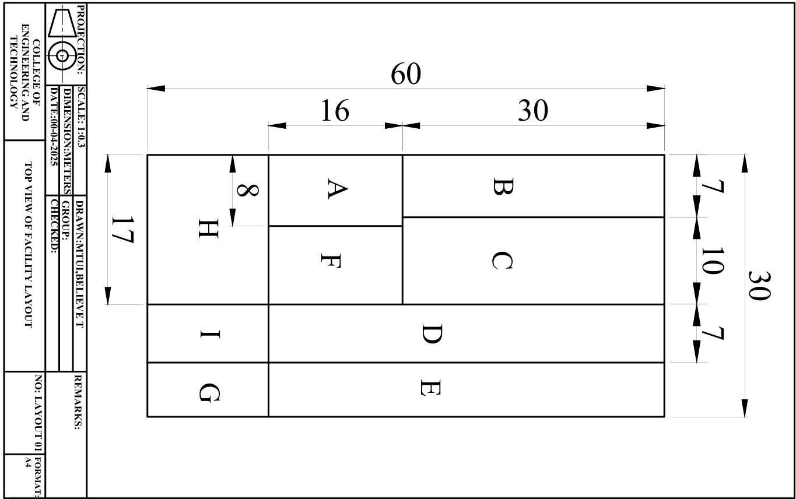

# 3.3 Data Analysis Methods

The collected data was analyzed using computational tools and statistical techniques to assess current facility performance and optimize the layout, included tools and software are;

1. **ARENA Simulation software (From Rockwell Automation)**
2. **FlexSim Simulation software.**

## 3.3.1 ARENA Simulation Analysis

ARENA simulation software was used to create a digital model of the existing facility layout, simulating the movement of materials and workers. The analysis included:

* **Process Flow Mapping:** Representing the production system as discrete events to identify inefficiencies.
* **Cycle Time Analysis:** Measuring time taken at each workstation.
* **Queue Analysis:** Identifying workstations with high waiting times.
* **Scenario Testing:** Simulating different layout configurations to compare efficiency metrics.

**( To be replace with the modified one)**

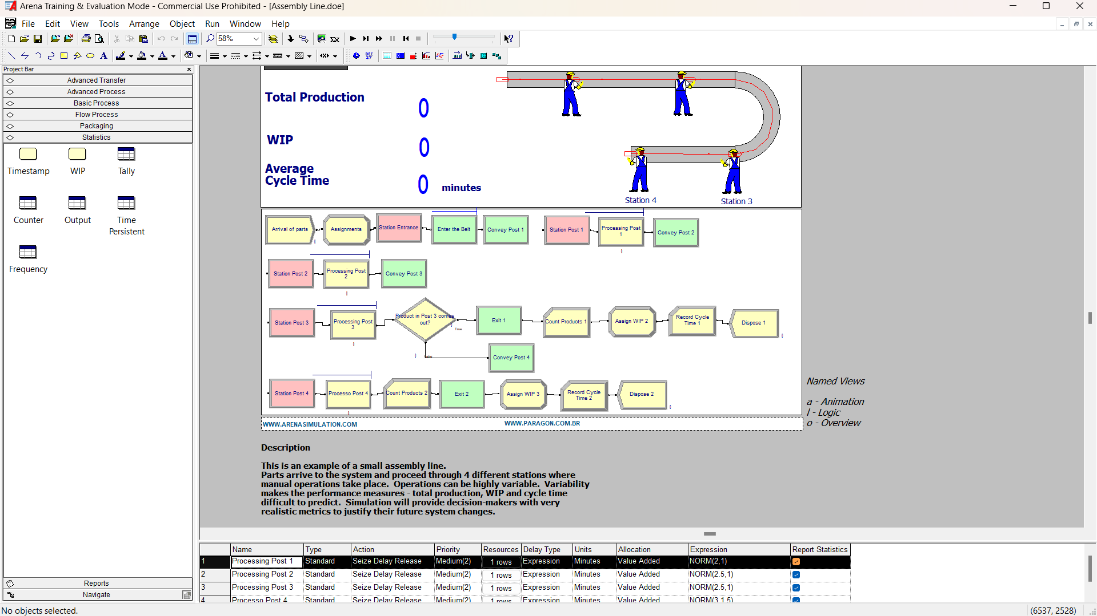

Figure 1:Showing Arena analysis

## 3.3.2 FlexSim Simulation Analysis

FlexSim was used to visualize and evaluate alternative layouts through a 3D simulation model. This tool allowed for:

* **Dynamic Flow Analysis:** Monitoring material movement in real time.
* **Bottleneck Detection:** Identifying points of high congestion.
* **Ergonomic Analysis:** Assessing worker movement efficiency and safety.
* **Space Utilization Metrics:** Measuring how well the facility space is used under different scenarios.

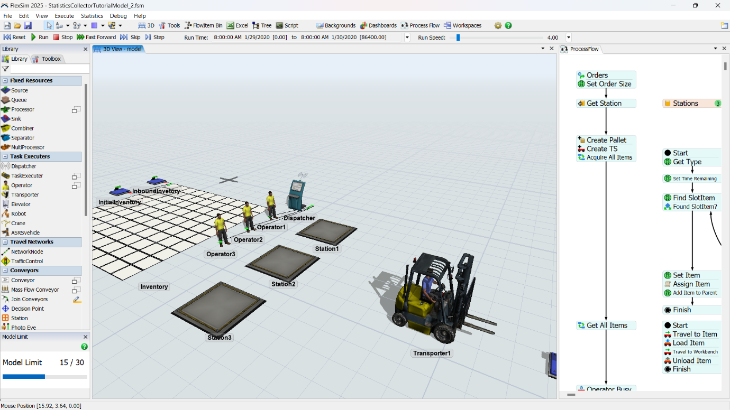

Figure 2:Showing FlexSim Simulation analysis

# 3.4 Facility Layout Genetic Algorithm optimization

Genetic Algorithm (GA) is a search and optimization technique based on natural selection and evolutionary principles. It mimics biological evolution: survival of the fittest, crossover (recombination), and mutation.GA is great for solving complex layout problems where you want the best arrangement of facilities to minimize cost, distance, or time with the application of python programming language is used to facilitate in the successful completion of the various stages.

The objective of this optimization is to minimize the total material handling cost at SITA Steel Industry by finding the optimal arrangement of facilities (machines) such as Slitting Machine, YPM2, YPM2H, YPM3, YPM10, Shear and Profiler. The optimization considers the flow of coils, handling costs, and distances between facilities

**Assumptions**

1. **All facilities (machines and departments) are modeled as rectangles** to simplify layout computation. If any facility is irregular in shape, it is approximated using a bounding rectangle.
2. **There are no immovable or fixed obstacles** such as columns, elevators, or structural barriers within the layout. This allows free reconfiguration of facility locations during optimization.
3. **Material movement is performed using overhead cranes and rail coil carriers**, which restrict the path to predefined horizontal and vertical travel axes.
4. **All transportation routes are assumed to be obstacle-free** for overhead cranes and coil carriers. Delays due to equipment traffic, congestion, or mechanical faults are modeled separately using simulation delay distributions.
5. **Material flow paths and handling frequency are determined by customer orders,** meaning that routing may vary by product type. For analysis, average flows between departments are used based on historical production data.
6. **The physical dimensions and positions of all facilities are known** or derived from CAD diagrams and blueprints, and their center coordinates (centroids) are used for calculating inter-department distances.
7. **The layout redesign focuses on manufacturing and material flow areas only,** excluding offices, admin blocks, and outdoor logistics zones.

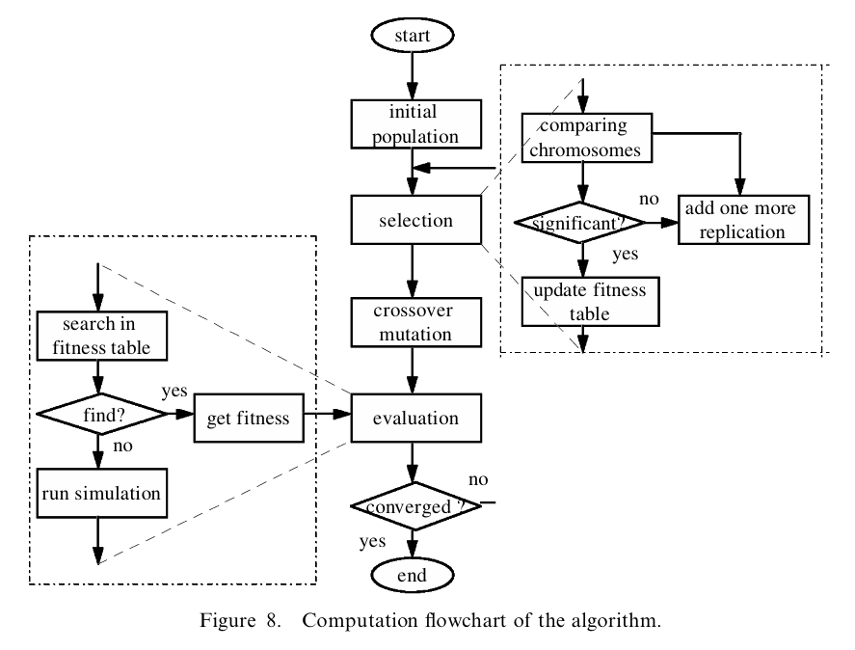

Figure 3:Genetic algorithm Flowchart

1. **Formulation of the objective Function**

**Objective:**

Minimize the Total Material Handling Cost.

Equation 2:objective Function

Where:

fij = flow (units moved) between facility i and j

dij= rectilinear distance between facility i and j

cij = cost per unit of distance for moving between i and j

**Key Data**

* **Distance matrix;** obtained using rectilinear (Manhattan) distances from center coordinates of machines A to I.
* **Flow matrix;** number of coils transported between machine pairs.

**Cost matrix;** calculated by multiplying handling frequency with fuel/labor costs

Where the current facility layout material handling cost is 

1. **Selection Strategy**

Select the best-performing facility layout configurations (chromosomes) from the population for reproduction in the next generation. The goal is to favor layouts with lower total material handling costs (i.e., better fitness values).

**Chromosome generation**

1. **Define the Genes:**

Each gene represents one facility or machine. For SITA Steel: Facilities A to I therefore 9 genes such as Genes = [A, B, C, D, E, F, G, H, I]. refer Table 1

1. **Encoding a Chromosome:**

A chromosome is a permutation of all 9 genes. For example, Chromosome: **[F, A, H, D, B, E, G, C, I]**. This sequence represents the order of placing machines in the layout.

1. **Ensuring Feasibility:**

All 9 facilities must appear once (no repetition).

Check for:

1. Valid layout area (≤ 1800 m²).
2. No overlap between facilities (respect spacing).
3. Logical material flow compatibility (optional constraint).
4. **Generation Method (Initial Population):**

Use random shuffling of the python programming language to generate chromosomes:

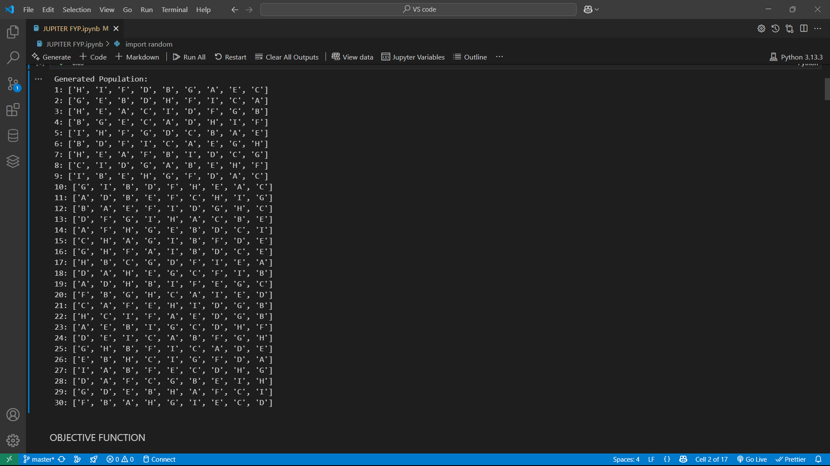

1. **Chromosome as a Data Structure:**

Chromosome are the Stored as a list or string. Then used in crossover, mutation, and evaluation. with the help of the slicing method of represent and construct **two-dimensional facility layouts.** facility’s floor space is split into **non-overlapping rectangular regions** using a **series of vertical and horizontal cuts.** These divisions are structured in a binary tree called a **slicing tree**, which determines how the layout is partitioned.

Steps in slicing method

1. Identification of the facilities and their dimensions
2. Chromosome definition
3. Construct the slicing tree; At this step the binary tree is formed from the chromosome generated by python random using facilities and slicing operator such as * for horizontal and V for vertical slicing.
4. Decoding of the slicing tree: The recursively dividing of the facility layout are using slicing direction. The allocation of the sub rectangles obtained are based on the tree structure and the facility are constraints.
5. Coordinated assignment: Here split the current rectangle either horizontally or vertically. Then Assign coordinates to the resulting sections. For each facility (leaf node); Assign its exact position (center coordinates or bottom-left corner) based on its rectangle
6. **Crossover Strategy**

Generate new facility layout configurations (offspring) by recombining the selected parent chromosomes from Step 2. The goal is to explore new layout possibilities by combining good features from different parents.

Crossover Permutation-Based Chromosomes.

In facility layout problems, each chromosome is a **permutation** of facilities (e.g., A–I). Therefore, a special crossover method is required to ensure:

* No duplicate facilities
* All facilities are included once

**Method: Order Crossover (OX)**

**Steps:**

1. **Select two parent chromosomes** (e.g., Parent 1 and Parent 2).
2. **Choose two random crossover points** in the chromosome.
3. **Copy the segment between the crossover points from Parent 1 to the child.**
4. **Fill the remaining positions with facilities from Parent 2,** in the order they appear, skipping those already copied.

**Example:** Let:

Parent 1 = [A, B, C, **D, E, F**, G, H, I]

Parent 2 = [H, D, F, **A, G, C**, I, B, E]

Crossover points = 3 and 6 (segment: D, E, F from Parent 1)

**Child Construction:**

1. Copy [D, E, F] from Parent 1 into Child at positions 3–5
2. Fill remaining slots from Parent 2: [H, A, G, C, I, B] skipping D, E, F
3. Final Child = [H, A, G, D, E, F, C, I, B]

Crossover Parameters:

* **Crossover Rate:** 80% (0.8)

Post-Crossover:

* Resulting children (new layouts) are added to the new generation
* Children are evaluated using the fitness function (same as Step 1)
* Unused parents may be carried forward if elitism is applied

Outcome

A new population (or partial population) of **child chromosomes** (facility layouts). These layouts reflect recombined traits from selected parents

**LIST OF LAYOUTS FROM JUPITER NOTEBOOK**

1. **Mutation Strategy**

Introduce small random changes in the offspring layouts (chromosomes) to maintain diversity in the population and explore new solutions that may be missed by crossover alone.

Mutation in Permutation-Based Chromosomes

Since facility layouts are permutations of departments (e.g., A to I), mutation operators must:

* Preserve valid permutations
* Avoid repeating or omitting any facility

**Swap Mutation methods for permutations**

1. Select two positions at random and swap the facilities.

Example:

Before: [A, B, **C**, D, E, F, **G**, H, I]

After: [A, B, **G**, D, E, F, **C**, H, I]

Mutation Rate

* Typical value: **0.01 to 0.1**
* Meaning: 1% to 10% of the population undergoes mutation each generation
* In facility layout problems: often **5%** is used as a starting point

After Mutation:

* The mutated chromosome is **evaluated again** using the objective function
* If feasible (fits within layout constraints), it's added to the population

Outcome:

A **mutated population** with new layout variants

1. **Evaluation and Replacement Strategy**

**Evaluation Phase**

For every chromosome (layout) is applied to the **objective function** to compute the total material handling cost. This fitness score represents how efficient a layout is in terms of cost.

Ensure **layout feasibility:**

1. No overlapping of machines or departments
2. Total layout fits within the overall available floor space
3. All spacing and clearance requirements are satisfied
4. Logical proximity for high-flow machine pairs is preserved where possible

**Replacement Strategies**

**Elitism**

This involves the preservation a specified number of the **top-performing chromosomes** (e.g., top 2–5 layouts) from the current generation. These elite solutions are automatically carried forward to the next generation to ensure the best designs are not lost during mutation or crossover. Encourages continuous improvement by maintaining a benchmark of quality.

# 3.5 Performance Metrics for Evaluation

To measure the effectiveness of the optimized layout, the following performance metrics are considered:

* **Material Handling Cost Reduction:** Evaluating cost savings from reduced material movement distances.
* **Production Lead Time:** Measuring improvements in cycle times and overall process efficiency.
* **Space Utilization Efficiency:** Assessing the percentage of available space effectively used.

Table 8:Summary of methodology

|  |  |  |  |
| --- | --- | --- | --- |
| **Specific Objectives** | **Type of Data** | **Data Collection Methods** | **Data Analysis Tools** |
| 1. To identify the critical parameters for an efficient factory layout | * Physical data (size, shape of the building) * Equipment data (type, size, and location of equipment) * worker movement workflow bottleneck * Cost data | * Literature review * Direct observations * Time-motion studies | * Descriptive statistics |
| 1. To evaluate the facility design strategies and approaches | * Space allocation and department layout * Flow matrix data * Distance between departments * Material handling costs | * Surveys and structured interviews * Direct measurement of distances * Document analysis (facility blueprints, production reports) | * Statistical analysis tools (Arena Output Analyzer,) |
| 1. To develop the new facility layout | * Physical dimensions of the factory floor * Machine placement and workflow optimization * Safety and ergonomic considerations | * CAD drawings * Previous research data * facility blueprints, production reports * Expert consultations | * AutoCAD * Simulation tools (ARENA) |

# 3.6 Validation and Implementation Strategy

The proposed layout is validated using real-time data and simulation outputs. The implementation process includes pilot testing before full-scale execution to ensure feasibility. Continuous monitoring and employee feedback are incorporated to make necessary adjustments for further improvements.

.

# CHAPTER FOUR

# RESULT AND CONCLUSION

# REFERENCE

Ardiansyah, D. P., Reynaldi, F. A. O., & Widaningrum, D. L. (2024). Improving Warehouse Layout Effectiveness and Process Picking Efficiency with the Discrete Event System Simulation Approach. *Procedia Computer Science*, *234*(2023), 1753–1760. https://doi.org/10.1016/j.procs.2024.03.182

Aslan, A., Vasantha, G., El-Raoui, H., Quigley, J., Hanson, J., Corney, J., & Sherlock, A. (2024). Smarter facility layout design: leveraging worker localisation data to minimise travel time and alleviate congestion. *International Journal of Production Research*. https://doi.org/10.1080/00207543.2024.2374847

Azadeh, A., Nazari, T., & Charkhand, H. (2015). Optimisation of facility layout design problem with safety and environmental factors by stochastic DEA and simulation approach. *International Journal of Production Research*, *53*(11), 3370–3389. https://doi.org/10.1080/00207543.2014.986294

Azadivar, F., & Wang, J. (2000). Facility layout optimization using simulation and genetic algorithms. *International Journal of Production Research*, *38*(17), 4369–4383. https://doi.org/10.1080/00207540050205154

Bobby, J., Jubin, J., & Mahesh, R. (2008). Analysis and Optimization of Plant Layout using RelativeAllocation of Facilities Technique. *International Journal of Emerging Technology and Advanced Engineering* , *9001*(8), 514. www.ijetae.com

Choirun, A., Brilliantina, A., & Triardianto, D. (2024). Facility layout design improvement in bottled drinking water at teaching factory. *IOP Conference Series: Earth and Environmental Science*, *1338*(1). https://doi.org/10.1088/1755-1315/1338/1/012070

Kovács, G., & Kot, S. (2017). Facility layout redesign for efficiency improvement and cost reduction. *Journal of Applied Mathematics and Computational Mechanics*, *16*(1), 63–74. https://doi.org/10.17512/jamcm.2017.1.06

Patil, N. D., Deshpande, V. A., & Gandhi, J. (2015). Techniques for Solving Facility Layout Problem: A Survey. *Afro - Asian International Conference on Science, Engineering & Technology AAICSET-2015*, *October*, 352–360.

Sharma, R., & Sharma, S. K. (2022). Facility layout optimization. *Industry 4.0 and Climate Change*, *VI*(4), 9–23. https://doi.org/10.1201/9781003293576-2

Suhardi, B., Juwita, E., & Astuti, R. D. (2019). Facility layout improvement in sewing department with Systematic Layout planning and ergonomics approach. *Cogent Engineering*, *6*(1). https://doi.org/10.1080/23311916.2019.1597412

# APPENDICES

## Appendix I: Research Budget

Table 9:showing the project Budget

|  |  |  |  |
| --- | --- | --- | --- |
| **S/No** | | **Materials/ Resources** | **Estimated Cost** |
| 1. | | Measuring Tools | 90,000/= |
| 2. | | Printing | 100,000/= |
| 3. | | Transportation | 80,000/= |
| 4. | | Internet access | 50,000/= |
| 5. | | Software **(**ARENA Simulation Software, AutoCAD and FlexSim**)** | 200,000/= |
| Total | | 520,000/= |

## Appendix Ⅱ: Showing the Timeline of Project

Figure 4:Showing the Timeline of Project

